**FRIENDS OF NORTH ELMHAM SCHOOL (F.O.N.E.S)**

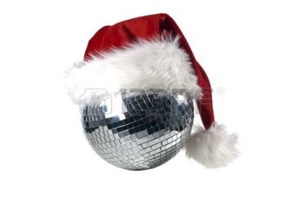Registered Charity Number: 1113450

**CHILDREN’S CHRISTMAS DISCO 2018**

7th November 2018

Dear Parents and carers,

I am delighted to tell you about our FONES annual Christmas disco for North Elmham School pupils. This event will be taking place on **Friday 7th December** at the **Institute Hall, North Elmham** (close to the village church). The disco will start at **5pm and go on until 7pm**.

The ticket cost is **£5.00 per child.** This cost will include a good quality pork or vegetable sausage in a roll, a soft drink, a present from Father Christmas and two hours of disco music! We will be running a tuck shop for the children to purchase additional soft drinks, sweets and crisps so please remember to give your child a named purse/wallet to keep their money safe. A price list for the tuck shop will go up on the FONES board nearer the time. No ticket needed as their names will be down on our list.

We will also be operating a register on the night, in order to sign the children in and out of the disco safely. Please inform a FONES member in advance if a different adult will be collecting your child. Please **DO NOT** send your child/children in with a camera or mobile phone as this is not allowed.

This event is aimed at giving the children a fun evening without parents/carers, and when you drop your discoers off, we will do our very best to make sure they have the best Christmas disco ever! Please leave your child at the door once registered, and on your return you will be shown into the small hall at the back of the institute. From here you will be asked to go into the large disco hall 10 at a time to collect your child/children. This is done for the safety of the children, and will help make sure that your child goes home safely with you. There will be lots of FONES members and helpers at this event, ensuring the well-being and safety of the children. However, we do appreciate that some children may need a little more help. If you need to be at the disco with your child for their safety, please feel free to speak to myself or any other FONES Member, Mrs Chambers and we can arrange this.

**Please return all reply slips to the office, clearly marked “Christmas Disco” by MONDAY 19th November at the very latest. This will ensure we get enough stock for the numbers we receive back.**

May we take this opportunity to wish you all a very Merry Christmas and a Happy New Year when it arrives.

With best wishes, Sharon & the FONES Committee 