**BOOKS FOR SCHOOLS**

It’s time to start collecting we have begun our campaign.

This is your chance to help your school win its share of £20,000 in books to inspire, inform and entertain the next generation of readers.

The tokens will appear in the Eastern Daily Press and also its sister publications across the region for parents, school friends and staff to collect.

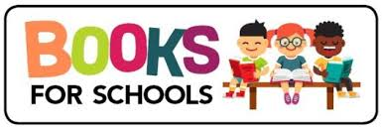We would ask you to please donate the tokens to the school where every 1000 tokens collected the school will receive £100-worth of free books.