**Friends of North Elmham School (F.O.N.E.S)**

Registered Charity No: 1113450

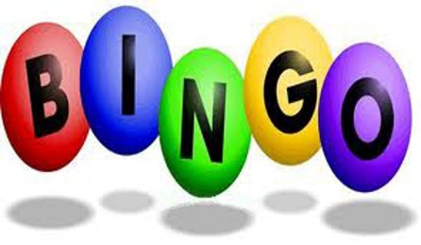 Dear Parent/Carer 19th September 2018

**Re: Autumn Bingo Evening**

Following the success of our earlier Bingo Evening back in June, The Friends of North Elmham School are pleased to announce that we will be holding the event again to help raise much needed funds to give back to the School. As School budgets are becoming tight, every penny really does help to keep our Village School running.

This year’s bingo evening will be held on **Tuesday 2nd October 2018**, in the **school Hall**, from **7pm** until around **9pm**. The evening will consist of 6 games of bingo, costing a total of £5, each with a prize for a complete line and then another prize for a full house. There will also be a refreshment break halfway through.

We do help that you can come along for an evening of fun and support us.

We will also be holding a raffle at the end and we would be most grateful if you could help by donating any raffle prizes. A bottle of wine, box of chocolates, plants, toiletries ect. Please send your donations direct to School where we have a box in the foyer. Thank you very much!

We look forward to seeing you at the bingo evening and thank you for your continued support.

Yours faithfully,

Sharon Phillips

Chairman

Friends of North Elmham School